You want to schedule a list of jobs in d days. Jobs are dependent (i.e To work on the ith job, you have to finish all the jobs j where 0 <= j < i).

You have to finish **at least** one task every day. The difficulty of a job schedule is the sum of difficulties of each day of the d days. The difficulty of a day is the maximum difficulty of a job done on that day.

You are given an integer array jobDifficulty and an integer d. The difficulty of the ith job is jobDifficulty[i].

Return *the minimum difficulty of a job schedule*. If you cannot find a schedule for the jobs return -1.

**Example 1:**

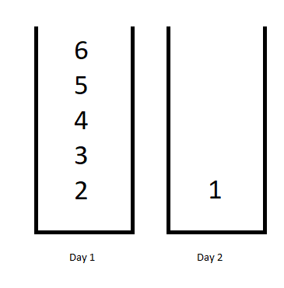

Input: jobDifficulty = [6,5,4,3,2,1], d = 2  
Output: 7  
Explanation: First day you can finish the first 5 jobs, total difficulty = 6.  
Second day you can finish the last job, total difficulty = 1.  
The difficulty of the schedule = 6 + 1 = 7

**Example 2:**

Input: jobDifficulty = [9,9,9], d = 4  
Output: -1  
Explanation: If you finish a job per day you will still have a free day. you cannot find a schedule for the given jobs.

**Example 3:**

Input: jobDifficulty = [1,1,1], d = 3  
Output: 3  
Explanation: The schedule is one job per day. total difficulty will be 3.

**Constraints:**

* 1 <= jobDifficulty.length <= 300
* 0 <= jobDifficulty[i] <= 1000
* 1 <= d <= 10